**Serious Space: Exploring the Interactive Art Experience of Data Gaze and Panopticism through Multimodal System**

Qixuan Zhang1, Yining Zhang1, Tong Zhu1, Jingya Li2

1Peking University, Beijing, China

2Beijing Jiao Tong University, Beijing, China

**Abstract.** With the rapid development of the digital era, challenges concerning user privacy, data surveillance, and individual autonomy have become increasingly pressing. This paper aims to explore the integration of Foucault's Panopticism theory and the concept of data gaze into the design of interactive installations, creating a medium that reflects the characteristics of modern surveillance while stimulating public discourse on data privacy. We have designed and implemented an interactive installation, "Serious Space," which integrates cameras, sensors, and computer vision algorithms to simulate the surveillance mechanisms of the panopticon prison. The installation transforms user behavioral data into real-time visual outputs, offering a direct representation of how data gaze operates in daily life. This design not only reveals the pervasiveness of data surveillance but also encourages users to critically reflect on their behaviors and privacy rights in the digital realm.

The paper begins by reviewing the core tenets of Foucault's Panopticism and analyzing its evolution in the context of digital technologies. Subsequently, the design process, technical implementation, and interaction mechanisms of "Serious Space" are described in detail. Based on user testing and feedback, the study evaluates the installation's effectiveness in raising public awareness of data privacy and surveillance issues. Finally, the paper discusses the potential of interactive media design in fostering social dialogue and protecting user privacy, offering insights for future design practices.

**Keywords:** Interactive Art Installation, Panopticism; Data Gaze; Privacy; Multimodal System

1. Introduction

The theory of panopticism[3], proposed by French philosopher Michel Foucault and inspired by Jeremy Bentham’s concept of the “Panopticon Prison,” describes a mechanism of micro-level power management achieved through spatial structures. In this mechanism, individuals under surveillance, unable to confirm whether they are being observed, are compelled to self-discipline under the pressure of potential observation. This form of power, through spatial and visual control, renders surveillance implicit and internalizes it within individual behavior. With the development of digital technology, the concept of the “data gaze” has gradually emerged as a new social phenomenon[4], emphasizing the instrumental role of data as a tool of science and technology while simultaneously revealing the underlying humanistic issues it entails. In the interaction between individuals and data, the focus of the gaze shifts from the subject to the object, as individuals increasingly feel the “gaze” of data, further deepening the mechanisms of implicit power infiltration. The intrinsic connection between panopticism and the data gaze lies in their shared method of power operation: the former functions through the control of physical space and vision, while the latter extends this control into digital and networked spaces[5]. By leveraging data analytics and algorithms, power institutions can predict and influence individual behaviors, further consolidating and expanding the boundaries of power. Interactive installations, as an innovative art form[6], integrate technologies such as sensors, cameras, and touchscreens, enabling audiences to directly influence the display and dynamic transformation of artworks through bodily movements, touch, or other forms of interaction[7]. By breaking away from the traditional one-way mode of art appreciation, these installations create immersive, multisensory experiences. This approach not only redefines the boundaries between art and technology but also transforms art from static presentation to dynamic participation[1], encouraging audiences to reflect deeply on the multidimensional relationships between art and life[8]. Due to their unique characteristics, interactive installations are often employed to educate and inspire, exploring social, cultural, and technological issues and serving as critical bridges connecting audiences with creators[2], audiences with technology, and audiences with social phenomena[9]. For instance, Chris Milk’s The Treachery of Sanctuary employs three giant screens and Kinect motion-sensing technology to transform participants’ movements into dynamic images, exploring the themes of “birth, death, and rebirth” in distinct phases. This installation blurs the boundaries between digital and physical reality, inviting audiences to contemplate themes of selfhood and transformation. Against this backdrop, this paper describes the design and implementation of an interactive installation, Serious Space, based on the theoretical concepts of panopticism and the data gaze. This installation integrates motion controllers, cameras, eye-tracking devices, and computer vision algorithms to simulate the surveillance mechanisms of the Panopticon. By collecting users’ facial expressions and behavioral data for real-time analysis, the installation generates visualized outputs that vividly present the operation of the data gaze in modern society. Through the interactive experience, the installation evokes a sense of tension and self-surveillance in users, prompting them to consciously adjust their expressions and behaviors. This process deepens users’ understanding of Foucault’s notion of self-discipline, illustrating how surveillance power is internalized and operationalized in the digital age.

1. Related Work

As data-driven intelligent technologies continue to advance, individuals increasingly feel as though they are living under the omnipresent "data gaze"[10]. This concept of the "data gaze" reveals, to some extent, how our behaviors as individuals have been transformed into data, rendering us what Foucault described as "measurable types," new objects of knowledge continuously shaped by data surveillance. In his book The Tensions of Algorithmic Thinking: Automation, Artificial Intelligence, and the Politics of Knowledge[11], David Beer critically examines the inherent tensions between humans and non-humans under algorithmic thinking, exploring the profound transformative impacts of technology and its mediated forms on contemporary culture. Many artists have previously explored the application of multimodal technologies in visual arts, using their works to provoke deep reflections on surveillance and power in modern society. For instance, Xu Bing’s Dragonfly Eyes[12], composed entirely of footage from surveillance cameras, examines the ubiquity and influence of surveillance power in contemporary life. Multimedia artist Lynn Hershman Leeson described algorithms as "the titanium white of our time, masking the primer of cultural negative spaces." Her interactive installation Shadow Stalker[13] constructs a series of locked rooms through algorithms, projections, and performances, using online data to track participants' spatial movements, exposing the invisible yet pervasive force of surveillance in daily life. Fei Jun, a professor at the Central Academy of Fine Arts, explores how machines perceive the relationship between human appearance and the world in his work Interesting World – Installation II[14], which categorizes the audience’s appearances and links them to global virtual scenarios.

With the rapid development of artificial intelligence, the capabilities and scope of social surveillance have significantly expanded, becoming increasingly covert and pervasive. Artist Trevor Paglen, in collaboration with AI researcher Kate Crawford, developed the selfie application ImageNet Roulette[15], which uses artificial intelligence to label human faces based on the widely used ImageNet machine learning training set, exposing stereotypes such as racism, sexism, and violence embedded in the dataset. By training on the "person" category of ImageNet[16], ImageNet Roulette deliberately highlights the offensive and biased descriptors it contains. Similarly, artist Christian Moeller’s experimental work Cheese[17] uses an emotion recognition system to evaluate the smiles of female actors. If the happiness level of their smiles falls below a set threshold, the system issues a warning, demanding more “genuine” smiles.

Compared to traditional artworks, this installation integrates multiple technological elements, including position tracking, eye tracking, and real-time facial expression data processing, forming a multimodal immersive experience system. This system dynamically generates visual content corresponding to the audience’s expressions and behaviors in real time, providing a more immersive and interactive experience. Moreover, this project materializes the abstract concept of the "data gaze" through various artistic elements, enabling the audience to directly perceive the mutual transformation of individual and data perspectives in the interaction between humans and data under the data gaze in modern society.

1. Implementation

The installation adopts interactive imagery as its presentation form, supported by interactive projection technology. The primary applications of interactive projection technology include immersive interactive projection spaces, wall projections, and interactive tabletops. Among these, interactive projection walls[18] are highly representative examples of interactive multimedia, widely praised for their engaging nature, strong visual impact, and effective narrative capabilities. This study focuses on the design of an interactive installation, presenting an immersive interactive projection wall space. Based on this concept, the Serious Space interactive imagery projection system was designed and developed.

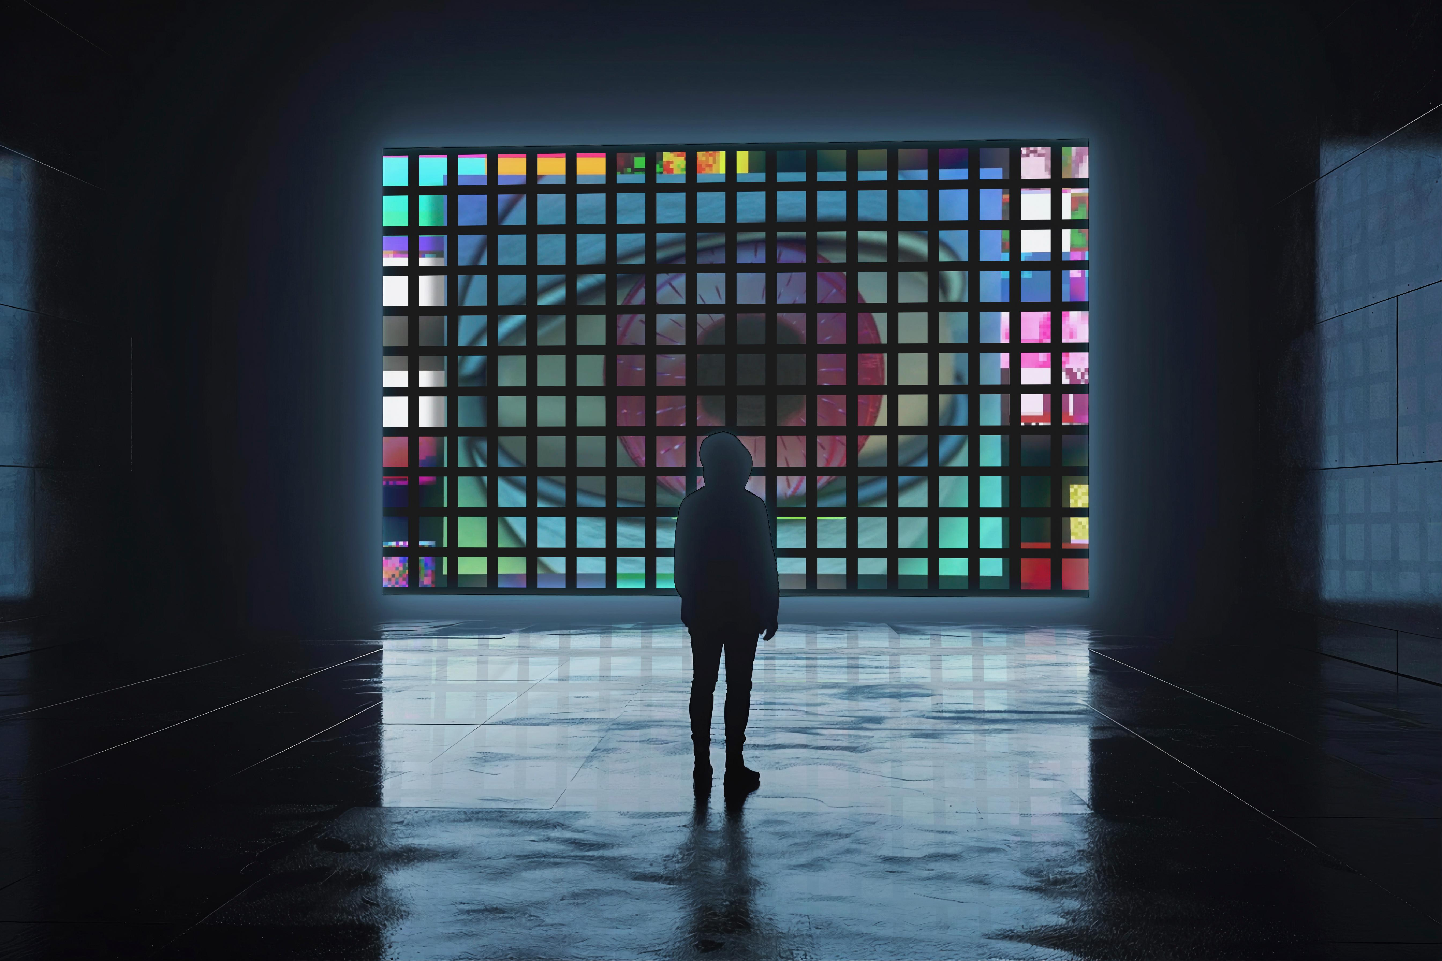

**Fig. 1.** Scenario concept diagram

* 1. **Art Concept of *Serious Sapce***

The Serious Space installation functions as a disciplinary device, allowing users to experience the tension of being monitored and the impulse of self-surveillance while engaging in interactive participation. It encourages users to consciously adjust their facial expressions and behavioral movements. By collecting participants’ biometric data and behavioral patterns, the installation generates personalized data profiles in real time, which are then artistically presented to the audience.

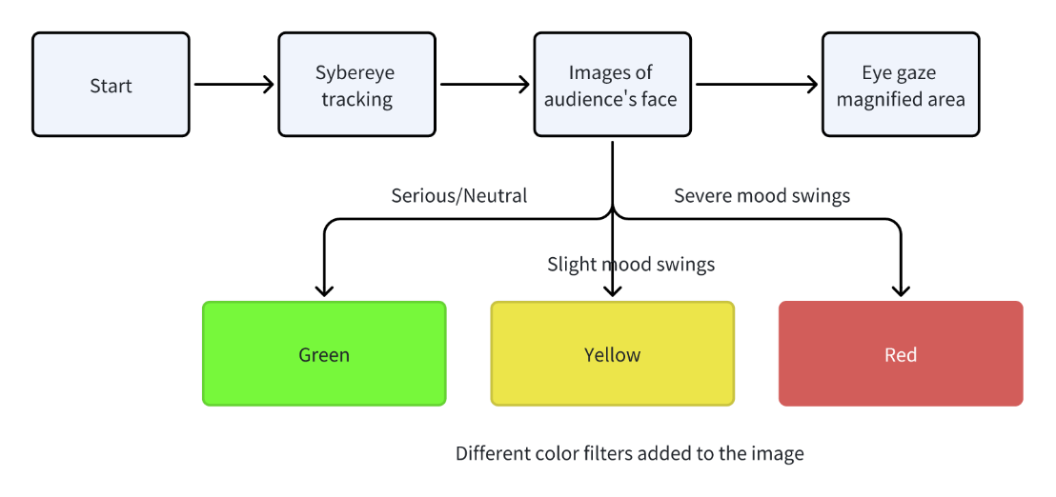

**Fig. 2.** Interactive function flow chart

* + 1. **Sybereye: Artificial Intelligence and Subjective Awareness**

“Sybereye” symbolizes the real-time surveillance capabilities of artificial intelligence through electronic visual effects. By dynamically tracking the position of viewers, it metaphorically reflects the inescapable fate of being observed in the era of big data.

* + 1. **Grid: Spatial Division and Discipline**

Inspired by Michel Foucault's Discipline and Punish, this work employs a grid to divide the screen into neatly arranged squares. Within each grid cell, the facial images of viewers, captured by cameras, are displayed. This visual representation recreates the transparency of space and the meticulous supervision of behavior imposed by disciplinary power.

* + 1. **Portrait: Temporal and Bodily Control**

Time is fragmented into seconds, as the camera periodically captures and displays the facial images of viewers. This process simulates the temporal organization and bodily control exercised by disciplinary institutions, emphasizing the sense of being monitored and the orderly structuring of behavior.

* + 1. **Red, Yellow, and Green Filters: Emotion Classification and Evaluation**

The work applies three color filters—red, yellow, and green—based on the intensity of the viewer’s emotional fluctuations. Red represents "danger," yellow signifies "potential risk," and green indicates "safety." This design visualizes the algorithmic capability to rapidly identify emotions and the stratification of social evaluation[19].

* + 1. **Magnifying Glass Effect: Progressive and Intrusive Surveillance**

The surveillance experience intensifies progressively based on proximity: from monitoring body position, to facial expressions, and eventually to eye movements and gaze tracking. The decreasing distance reinforces the gradual deepening and intrusive nature of surveillance, transitioning from the macro to the micro scale.

* 1. **Development**
     1. **Position Tracking based on Kinect V2**

The Kinect v2 is a device that integrates an RGB camera, depth sensor, and infrared sensor, enabling human pose recognition and skeletal tracking. In Unity, a Kinect support plugin was developed to acquire the position data of the human body, which is used to determine the distance of the viewer from the screen. By recognizing the position of the viewer’s torso (on the X-axis) via Kinect, the system helps determine the viewer's movement direction, which is then used to control the gaze direction of the SyberEye model.

* + 1. **Facial Expression-Driven Interaction**

We utilize a camera to capture facial expression data from users, enabling real-time image generation and feedback. The facial expression recognition functionality is primarily based on the OpenCV library for detecting and analyzing facial expressions. Frames are captured from the camera and pre-processed to enhance recognition accuracy, including operations such as scaling, cropping, and flipping. A pre-trained Convolutional Neural Network (CNN) model is then employed to analyze the facial image and classify the expression type. The recognized facial expressions are categorized into three groups: neutral (neutral, serious), mild emotional fluctuations (sadness, frustration, mild smile), and intense emotional fluctuations (anger, surprise, laughter). Based on the received facial expression data, the system dynamically adjusts the visual effects of the Stage.

* + 1. **Eye tracking**

Using the Tobii Eye Tracker 4C for eye tracking, this is a high-precision eye-tracking device developed by Tobii that enables users to achieve eye control and gaze interaction functionality. First, integrate the Tobii SDK into the Unity project, and then use the TobiiAPI.GetGazePoint() method to obtain the user's gaze point on the screen.

* 1. **Interaction Process**
     1. **Stage One**

In the first stage, when the user enters the interactive space, the system automatically detects the user's position through sensors and cameras in the environment. Once the user enters this interactive zone, an eye on the screen dynamically moves according to the user's location, with its gaze following the user's movements, creating a visual sensation of being watched. As the user moves to the center of the space, the eye’s gaze becomes more focused, marking the official beginning of the interaction between the user and the system. During this phase, the user may experience a sense of tension, akin to being monitored, while also triggering an emotional response of self-reflection. The eye’s gaze moves smoothly and naturally on the screen, precisely aligning with the user's position, thus generating psychological tension and signaling the commencement of the interaction.

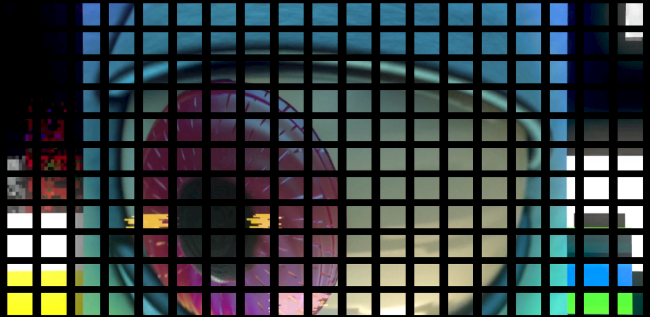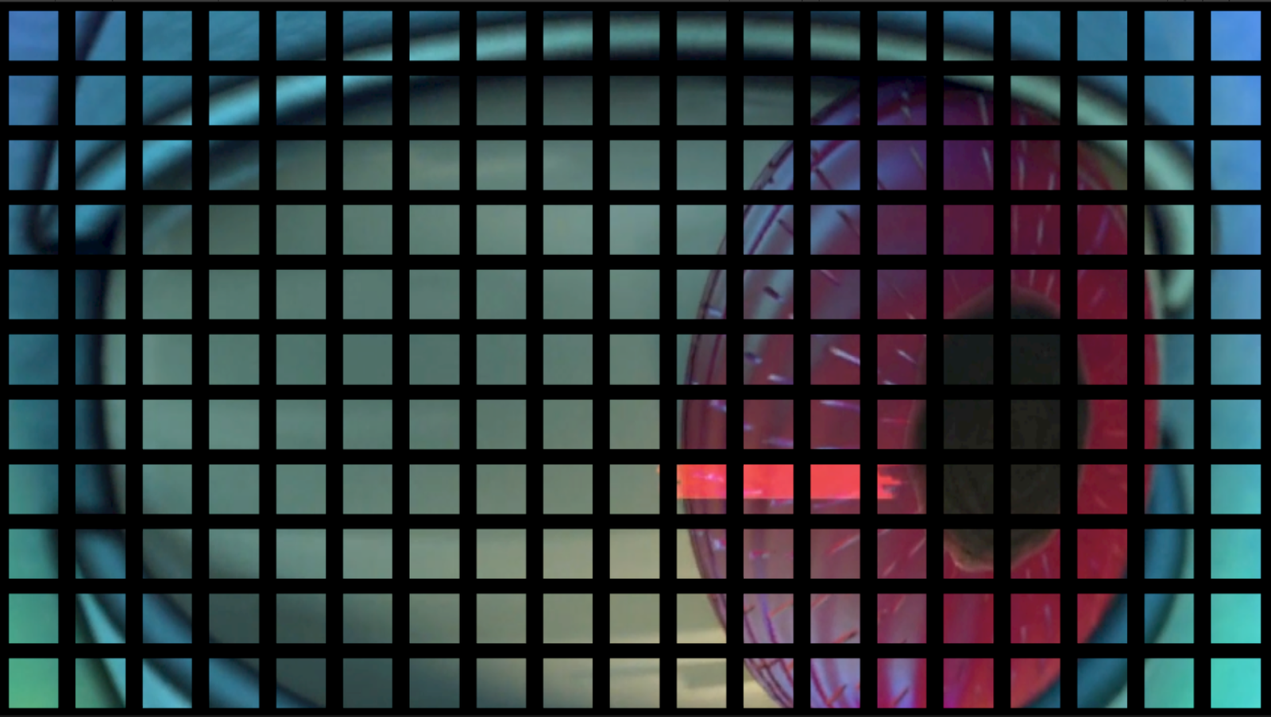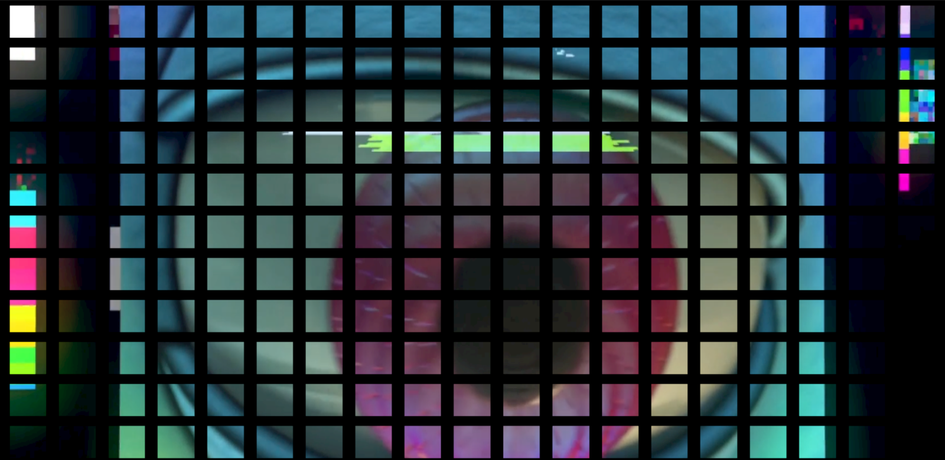

**Fig. 3.** Images of Stage1

* + 1. **Stage Two**

As the user progresses to the next phase, the facial expression recognition functionality is activated. The system uses the camera to capture the user’s facial expression data, analyzing the current emotional state and processing it. Based on the real-time facial data, the system generates customized visual feedback: depending on the user’s emotions (such as laughing, surprise, anger, or neutrality), different colored filters are automatically selected and projected. The filters gradually cover the entire screen in a grid-like pattern, and the progressive infiltration of these grids not only simulates the gradual changes in emotions but also creates a sense of layering and gradual transition in the visual effects. When the filters fully cover the screen, the integration of the user’s facial expression with the visual effects further reinforces the perception of “data gaze,” and the user feels the fusion of emotions with surveillance technology.

In this phase, the system cleverly uses the relationship between visual feedback and the user’s emotional expression, making each change in the user’s expression interact with the visual effects in the environment. As the filters appear, the user experiences not only the power of surveillance on a perceptual level but also an "exposure" of their emotional expressions through these evolving visual effects.

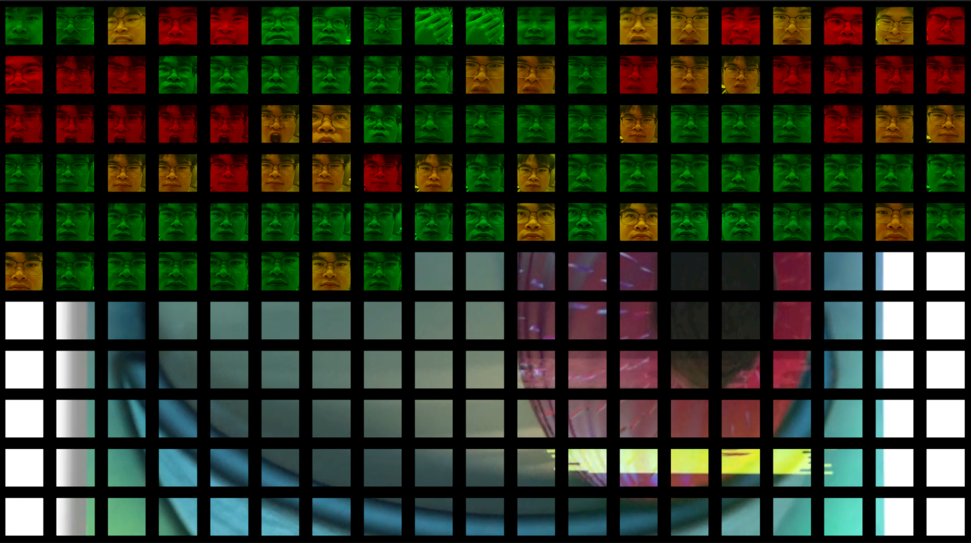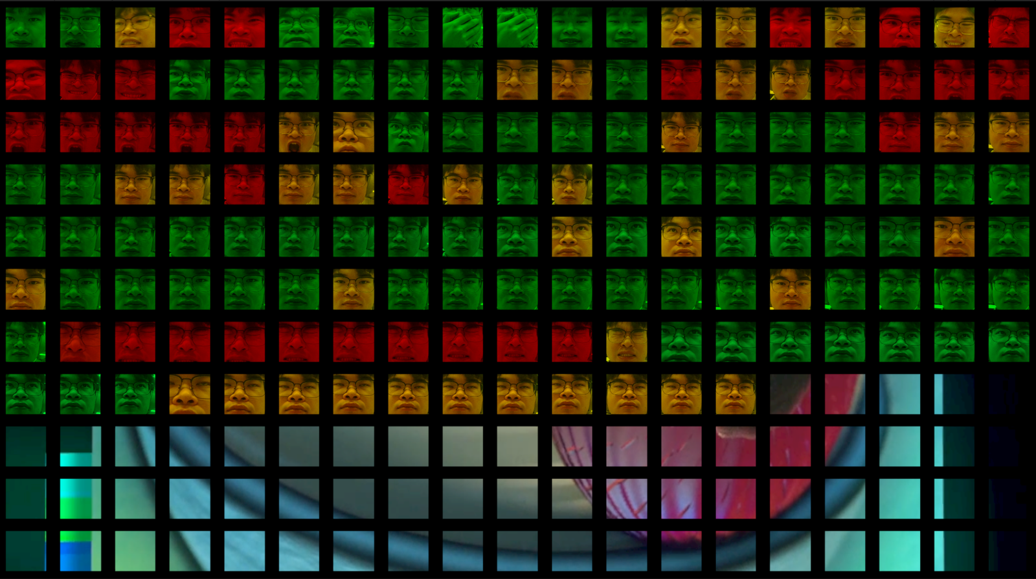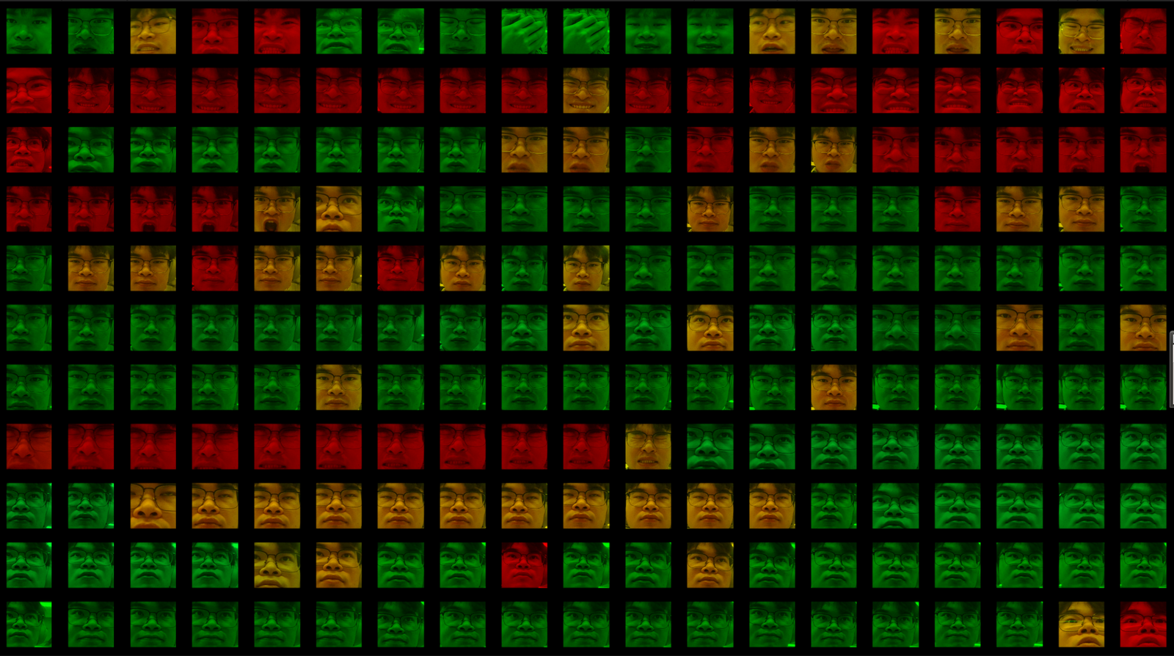

**Fig. 4.** Images of Stage2

* + 1. **Stage Three**

In the final tracking phase, the system begins real-time tracking and capturing of the user’s eye movements using an eye-tracking device. When the user focuses on a specific area of the screen, the location of the gaze is accurately projected onto the corresponding part of the screen. To enhance this interactive experience, when the user concentrates on a specific area, the system automatically zooms in and highlights that section, reinforcing the user’s sense of focus and choice.

This stage symbolizes “further surveillance and gaze.” The gaze point on the screen remains aligned with the user’s eyes, reinforcing the physical tracking and making the user feel their “manifestation” in the digital world. During this process, the user experiences their gaze being precisely tracked and reflected back into the environment, creating an immersive sense of being watched. Through zooming and focus effects, the system demonstrates the user's attention to a particular object, while also symbolizing how individual behavior is continuously monitored and magnified in modern society, thus provoking reflection on personal privacy and self-surveillance.

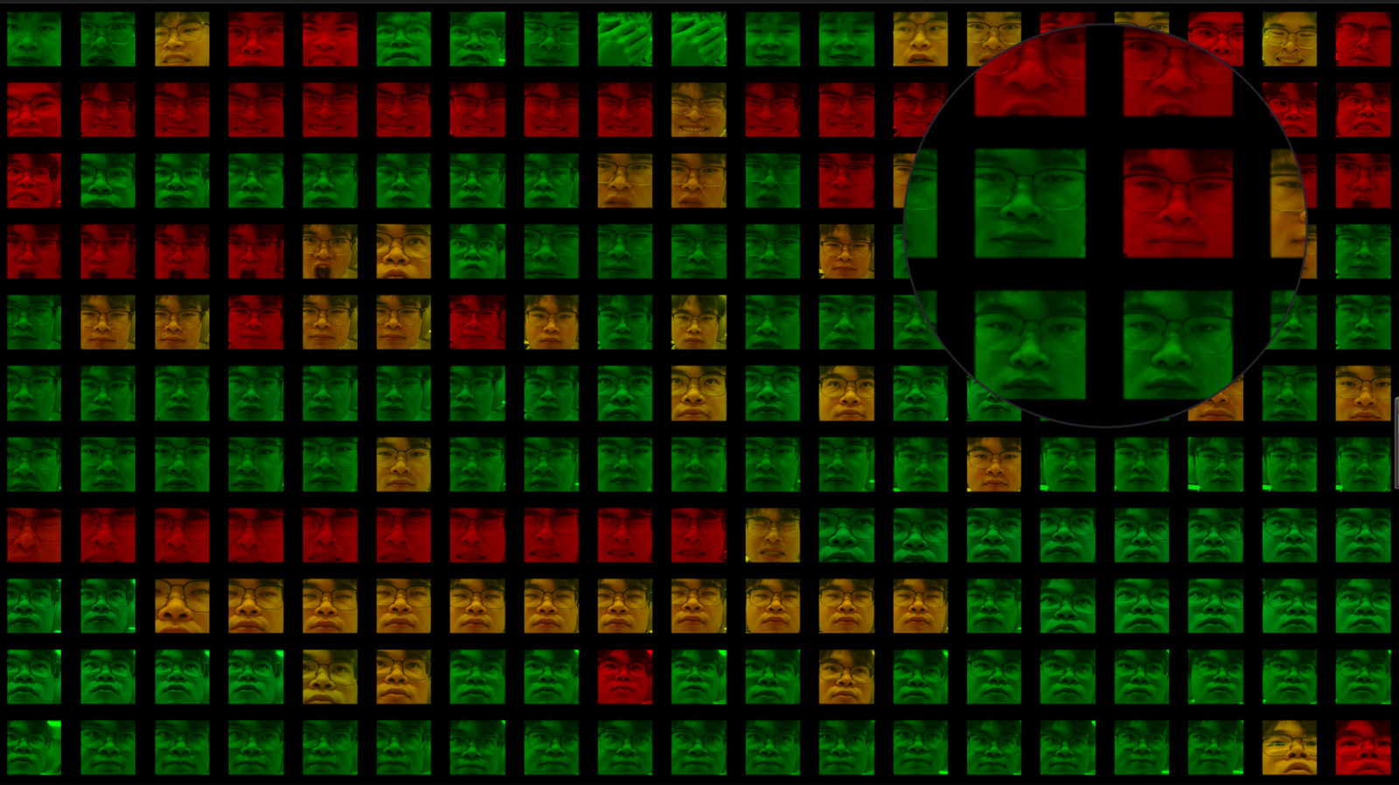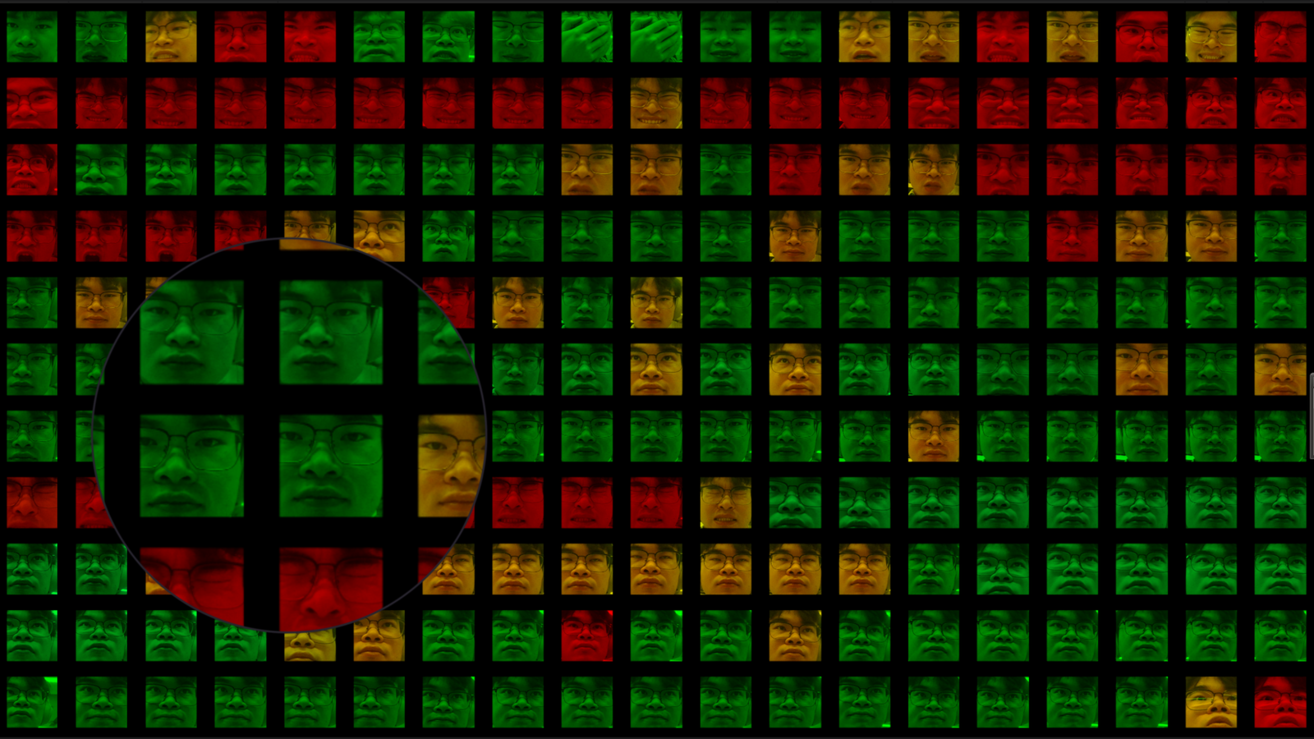

**Fig. 5.** Images of Stage3

1. Preliminary experiment
   1. Participants

This study involved 6 participants, who engaged in the interactive installation experience. The experiment took place at the Digital Entertainment Lab of our university. The participants consisted of three males and three females, aged between 18 and 35. Among them, one participant was familiar with Foucault’s theory of Panopticism or the concept of data gaze.

A semi-structured interview approach was adopted in this study to understand participants' overall experience and impressions of the interactive installation. The focus was primarily on their emotional reactions, associations, and personal interpretations of the thematic content. Through semi-structured interviews, we were able to gain in-depth insights into participants' emotional experiences and their reflections on the artwork.

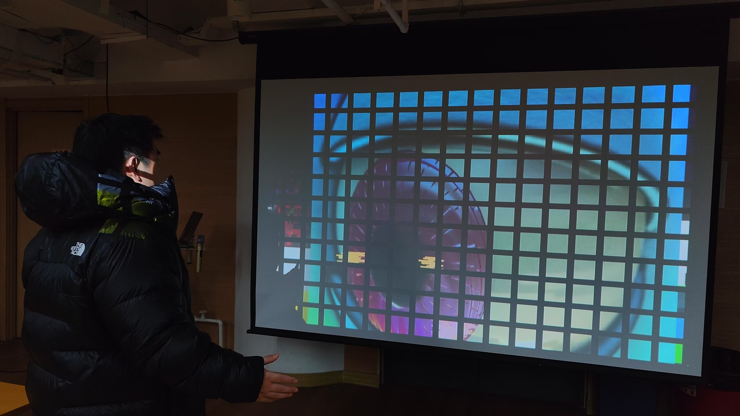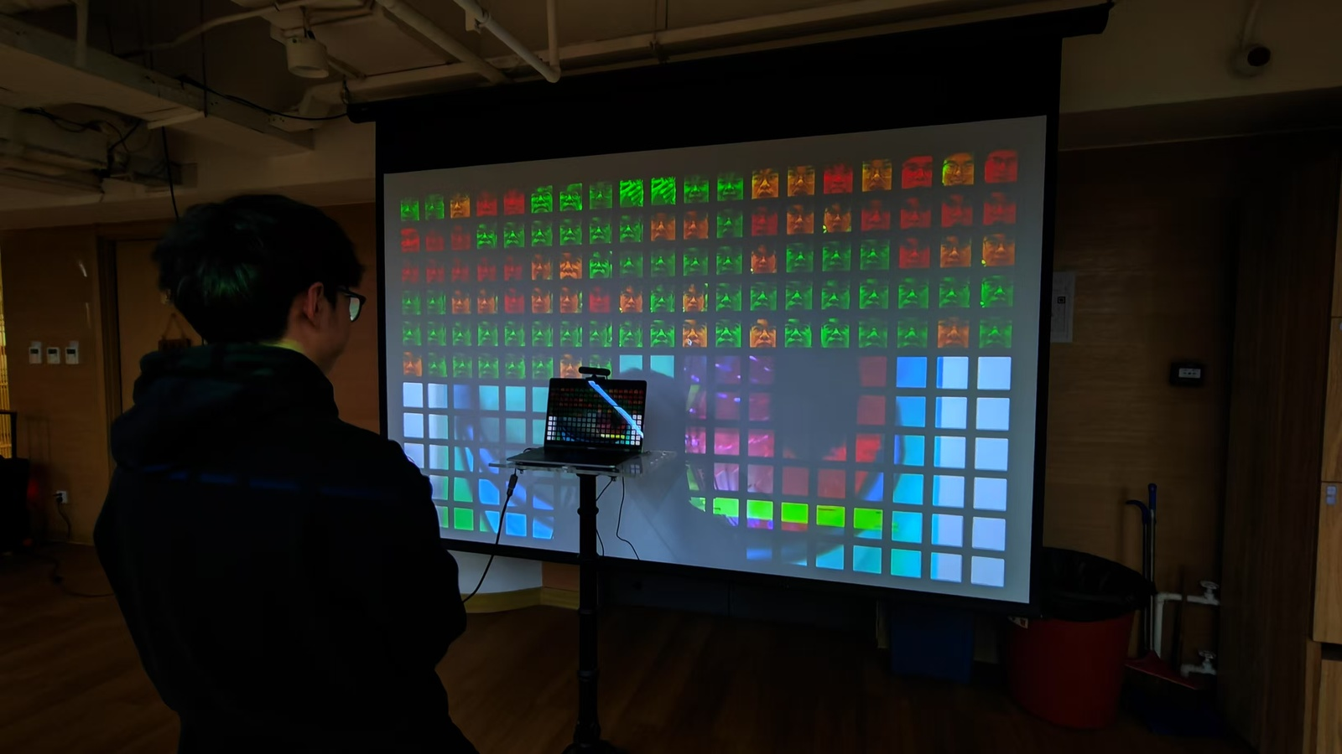

**Fig. 6.** Experiment site

* 1. **Results and Findings**
     1. **The Installation Evoked Concerns About Surveillance and Technology**

During the semi-structured interviews, participants frequently mentioned concepts associated with "technology," "surveillance," and "eyes." Most of the respondents (four out of six) expressed feelings of being observed during the interaction, which indicates that the installation successfully materialized Foucault's Panopticism and provoked profound reflections on surveillance societies. Specifically, when the installation simulated surveillance mechanisms and provided visual feedback to guide users, participants generally reported experiencing a sense of invisible surveillance pressure during the interaction. This response suggests that the installation not only functioned as a technological interactive experience but also served as a powerful warning about individual freedom and privacy rights.

* + 1. **Ease of Interaction and Control Stimulated Participants' Interest and Engagement**

Participants generally reflected that the design of the installation sparked a sense of "curiosity," wherein they were eager to continue interacting with the system to uncover more hidden visual effects or receive new feedback. One participant mentioned: "I really wanted to see what happens once all the boxes are filled, so I was happy to stay in front of the screen for a longer time." This design encouraged participants to maintain high levels of attention and focus throughout the interaction, greatly enhancing the immersive nature of the experience. Many participants stated that they gradually relaxed their initial apprehension and began actively testing and challenging the installation's reactions, thus increasing the overall fun and interactivity of the experience.

At the same time, the interactive design of the installation effectively enhanced the emotional connection between the participants and the system. Some participants expressed emotional fluctuations during the experience, including feelings of being "monitored," with a few attempting to "test" the system’s responses by performing different behavioral patterns, such as fake smiles or expressions of surprise. This emotional engagement and conscious interaction with the technology transformed the installation from a mere mechanical device into a medium capable of eliciting emotional responses and intellectual discourse.

* + 1. **Successfully Conveying the Effects of Foucault's Panopticism and the Data Gaze**

The results of the experiment indicate that the installation successfully materialized the concepts of Panopticism and the data gaze to a certain extent. Most participants reported that they were able to intuitively perceive their role as "the observed," especially when the system continuously tracked their behavior through visual feedback, which effectively stimulated their self-awareness. This response aligns with the core idea of Panopticism, where continuous, inescapable surveillance mechanisms lead individuals to internalize discipline and demonstrate self-restraint. Participants generally stated that this interactive experience made them aware of their exposure in the digital age and the potential risks of privacy violations. Furthermore, it prompted them to reflect on the growing technological control and data surveillance in modern society.

In summary, the ease of understanding and operation of the installation effectively attracted participants' interest and stimulated their curiosity and engagement. This, in turn, led them from merely interacting with the installation to reflecting on broader societal and cultural issues. The success of this design validates the potential of interactive art installations to enhance public awareness of technological issues and provides valuable insights into how art forms can stimulate deeper contemplation on complex social problems.

1. Conclusion

In terms of future work, several avenues are worth exploring. First, more artistic exploration can be done in the facial expression part, such as simulating short-distance video platforms to add virtual images or AR elements. In addition, the source of data analysis can be increased, and quantitative analysis can be performed on the frequency of expression, the traces of visual movement, etc., which will allow us to more comprehensively explore the intersection between technology, surveillance, and human behavior.

Moreover, future iterations of Serious Space could be tested in different social and cultural contexts to evaluate how the installation's effects vary across different demographics. This would not only enrich the understanding of "data gaze" but also contribute to the ongoing discourse on privacy, autonomy, and surveillance in the digital age. Finally, we envision the potential for expanding the project into a series of installations, each tackling different facets of surveillance, to further provoke critical thinking and public engagement around the ethical implications of emerging technologies.

In this paper, we have designed, presented, and conducted a pilot study of an interactive art installation titled Serious Space. Our work contributes to the understanding of how theoretical concepts, such as Foucault's Panopticism and the notion of "data gaze," can be applied in contemporary interactive media art. Through the integration of sensors, cameras, eye-tracking devices, and computer vision algorithms, Serious Space simulates surveillance mechanisms, offering users an immersive experience that both reflects and critiques the dynamics of modern data monitoring.

This installation reveals how surveillance in the digital age extends beyond physical spaces and into the realm of data-driven control, where individuals unknowingly become subjects of constant observation. By translating the concept of "data gaze" into an interactive, participatory format, Serious Space allows users to experience the psychological effects of surveillance, including tension, self-regulation, and the internalization of control mechanisms.

In conclusion, Serious Space serves as a compelling example of how interactive art can engage with contemporary social and technological issues, offering a powerful medium for reflection, critique, and dialogue on the pervasive influence of surveillance and data collection in modern life.

References

1. Li, Jingya, and Zheng Wang. "An interactive augmented reality graph visualization for chinese painters." Electronics 11.15 (2022): 2367.
2. Hu, Jun, et al. "Attractiveness of an interactive public art installation." Distributed, Ambient, and Pervasive Interactions: First International Conference, DAPI 2013, Held as Part of HCI International 2013, Las Vegas, NV, USA, July 21-26, 2013. Proceedings 1. Springer Berlin Heidelberg, 2013.
3. Foucault M. Panopticism[M]//The information society reader. Routledge, 2020: 302-312
4. Beer D. The data gaze: Capitalism, power and perception[J]. 2018.
5. RICHARDSON T. Space, gaze and power: A foucauldian methodology for fashion advertising analysis[J]. Fash Theory, 2021, 25(2): 195-214.
6. Yang Rongjun, Sun Xianhua, and Xue Chong, On the Technological Innovation and Development of Interactive Installation Art, Art Education Research, No.2, pp. 30-31, 2022.
7. Stern N. Interactive art and embodiment: The implicit body as performance[M]. Gylphi Limited, 2013.
8. Paul C. Digital art[M]. Thames & Hudson, 2023.
9. Takala G B. The interactive creativity of the digital era: Exploring how media art redefines the relationship between audience and artwork[J]. Studies in Art and Architecture, 2023, 2(3): 28-44.
10. Bossewitch, Jonah, et al. "Digital futures in mind: Reflecting on technological experiments in mental health & crisis support." Available at SSRN 4215994 (2022).
11. Beer, David. The tensions of algorithmic thinking: Automation, intelligence and the politics of knowing. Policy Press, 2022.
12. Guan, Haowen. "Power and Gaze in Xu Bing’s Dragonfly’s Eye." 2nd International Conference on Education, Language and Art (ICELA 2022). Atlantis Press, 2023.
13. LEESON L H.Shadow Stalker (2018-2021) [EB/OL]. 2021. [https://www.lynnhershman.com/proiect/shadow-stalker/.](javascript:void(0);)
14. Li Yilin and Zhu Shiyuan, "Interactive Video Device Design from the Perspective of Aesthetic Psychology: Taking the Interesting World as an Example", Digital Communication World, No.10. Pages 220-221, 2021.
15. CRAWFORD K, PAGLEN T. ImageNet Roulette[EB/OL]. 2009. [https://www.chiark.greenend.org.uk/~ijackson/2019/ImageNet-Roulette-cambridge-2017.html.](javascript:void(0);)
16. LAB S V.ImageNet[EB/OL]. 2021. [https://www.image-net.org/](javascript:void(0);)
17. MOELLER C.Cheese[EB/OL]. 2003. [https://christianmoeller.com/Cheese.](javascript:void(0);)
18. Kim, Hyosun, and Dieter W. Fellner. "Interaction with hand gesture for a back-projection wall." Proceedings Computer Graphics International, 2004.. IEEE, 2004.
19. Xin, John H., et al. "Cross‐regional comparison of colour emotions Part I: Quantitative analysis." Color Research & Application: Endorsed by Inter‐Society Color Council, The Colour Group (Great Britain), Canadian Society for Color, Color Science Association of Japan, Dutch Society for the Study of Color, The Swedish Colour Centre Foundation, Colour Society of Australia, Centre Français de la Couleur 29.6 (2004): 451-457.